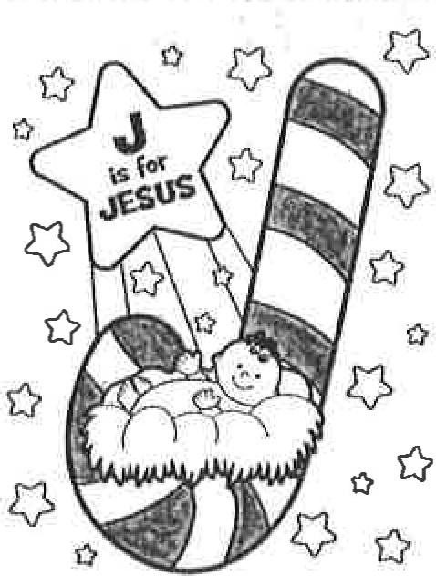
The Candy Cane Legend
(Based on circulating legends of the candy cane)
May our eyes and ears of faith be newly opened
Today, I share with you the Candy Cane Legend
Many, many years ago, so the story is told
A special Christmas candy, a candy maker wished to mold
Wanting to include signs of Jesus and his ministry
He began with a stick of pure white hard candy
It was shaped into a 'J' for Jesus the Lord
Who came to free us from our sins and all discord
White to symbolize his virgin birth and sinlessness
Hard to represent his rock foundation and faithfulness
Turn it around and you have a humble shepherd's staff
Yes, Jesus our Good Shepherd would die on our behalf
The maker thinking that this sacred treat was too plain
Decided to highlight the candy cane with a red stain
Adding red stripes to signify the blood of Jesus
Shed on the wooden cross; this saving gift so precious
This Christmas let us look deeper and beyond the surface Seeing the candy cane and its true meaning so wondrous
Fr. Robert Hétu
Copyright 02004 & 2015 & 2025 R.J. Hétu

